
BOSTON
INTERNATIONAL COLLEGE
END TERM EXAM
Level: Bachelor |  | Year : 2024
Program: BCSIT Sem: II |  | Full Marks : 100
Course: Data Structure and Algorithm |  | Time : 3 hrs

Candidates are required to give their answers in their own words as far as practicable. The figures in the margin indicate full marks.

Group A
Very Short Answer Questions
Attempt all questions. Give your answer in few lines. 10*2=20
- Compare primitive and non-primitive data types.
- Why do we use a queue?
- Evaluate the postfix expression 3 4 * 6 – 3 /.
- How can we create a node in a linked list?
- What is perfect hashing?
- Perform depth-first search traversal for the given graph.
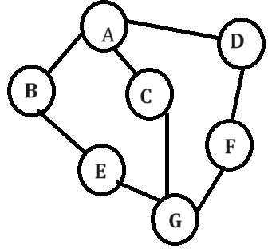
- Differentiate between internal and external sorting.
- Differentiate between strictly binary tree and complete binary tree.
- How many spanning trees can a complete graph have?
- What is asymptotic notation?

Group B
Short Answer Questions
Attempt any five questions. 5*10=50
- Explain the Tower of Hanoi using the C program.
- Why are data structures crucial in programming? Discuss with examples how choosing the right data structure can significantly impact the efficiency of algorithms.
- What is postfix expression? Give the postfix form of the following expression using the stack method: A+(B*C-(D/E^F)*G)*H
- What are different operations performed in Queue? Write the algorithm for en-queue and de-queue operations.
- Explain the tree traversal of a binary tree. Given the pre-order and In-order traversal result of a binary tree, construct the original tree.
Post-order: HDIEBJFKLGCA
In-order: HDBIEAFJCKGL
- Define sorting. Write an algorithm for selection sort and trace the algorithm for the following data.
54, 26, 93, 17, 77, 31, 44, 55, 20

Group C
Long Questions 3*10=30
- In a singly linked list, how would you insert a new node before a specified node and delete a node after a specified node?
- Define Hash Function and Load Factor. For the input {89, 18, 49, 58, 69, 78, 33, 43, 42, 25} in a hash table of size 10, show the resulting Hash Table using Linear Probing and Separate Chaining.
- Find the minimum spanning tree from the given graph using Kruskal’s Algorithm.
